**Computer Vision Term Project Progress Check 3**

Contents

Frist Attempt 1

Second Attempt 3

Third Attempt 5

Our Results So Far 9

What is for Future? 12

# Frist Attempt

Developed a python program that converts a single 2D image into 3D mesh using the following libraries.

1. Torch
2. Transfomers (GLPNImageProcessor, GLPNForDepthEstimation)
3. Open3d
4. Matplotlib
5. Pillow
6. Numpy

**Description**

This code performs depth estimation and 3D reconstruction from an image using a pre-trained model and Open3D. It first loads and resizes an input image, passes it through a GLPN (Global Planar Network) model to predict the depth map, and visualizes both the image and its corresponding depth. It then processes the depth and RGB data to create a 3D point cloud and refines it by removing statistical outliers. After estimating normals and orienting them, it applies surface reconstruction to generate a 3D mesh from the point cloud. The mesh is rotated and visualized

**Result**

**Depth Estimation**

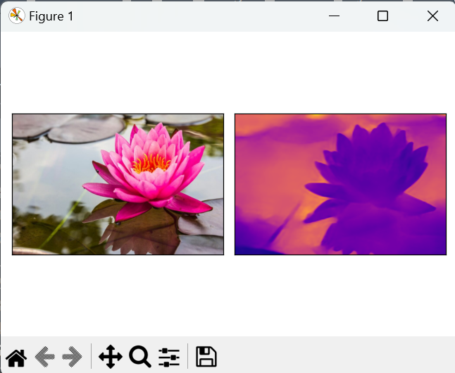

**Output**

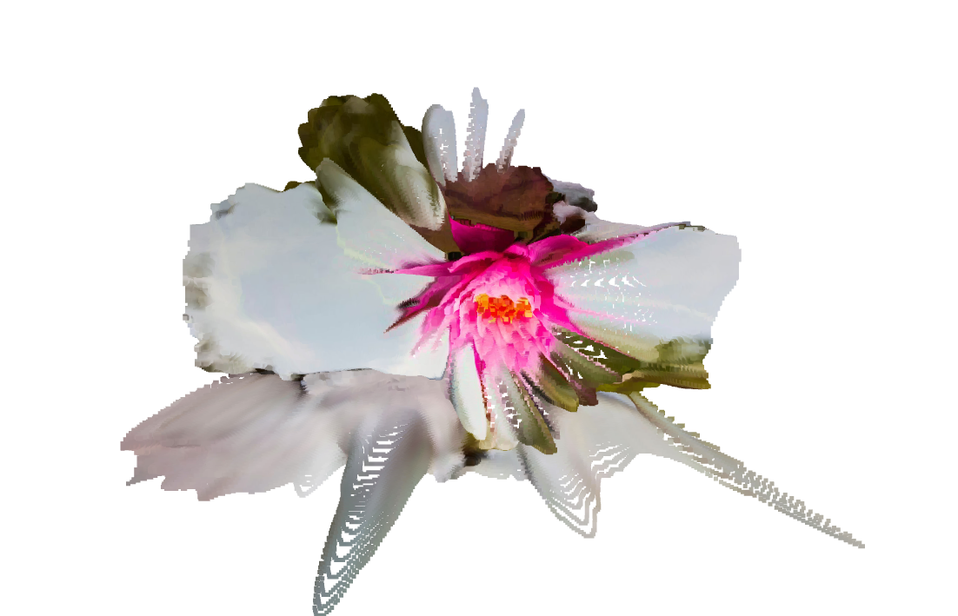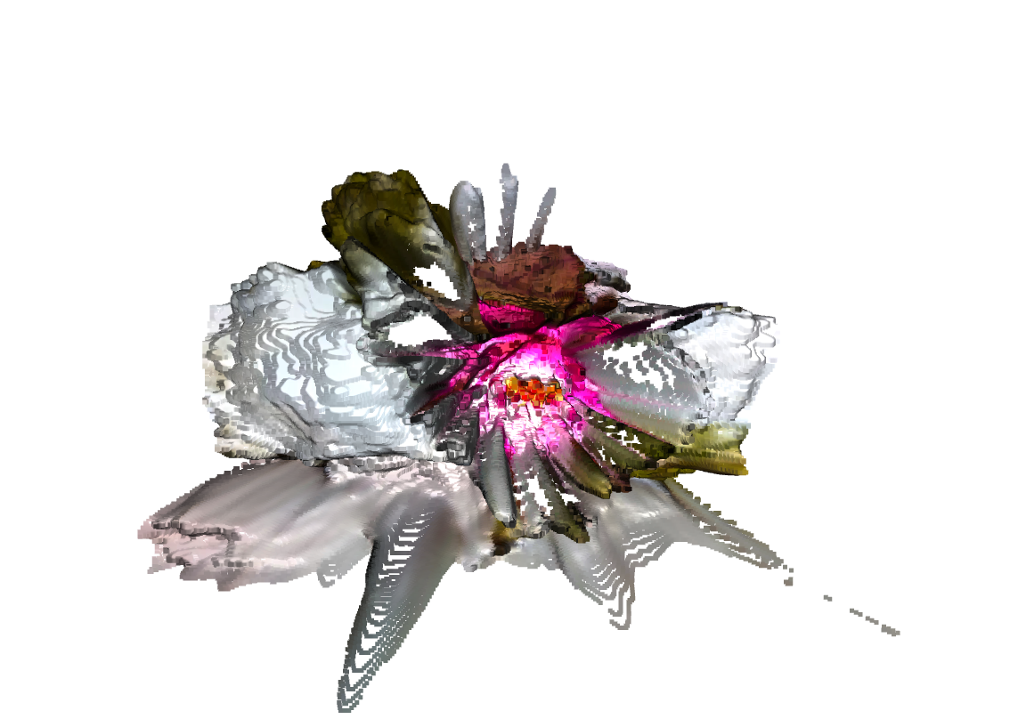

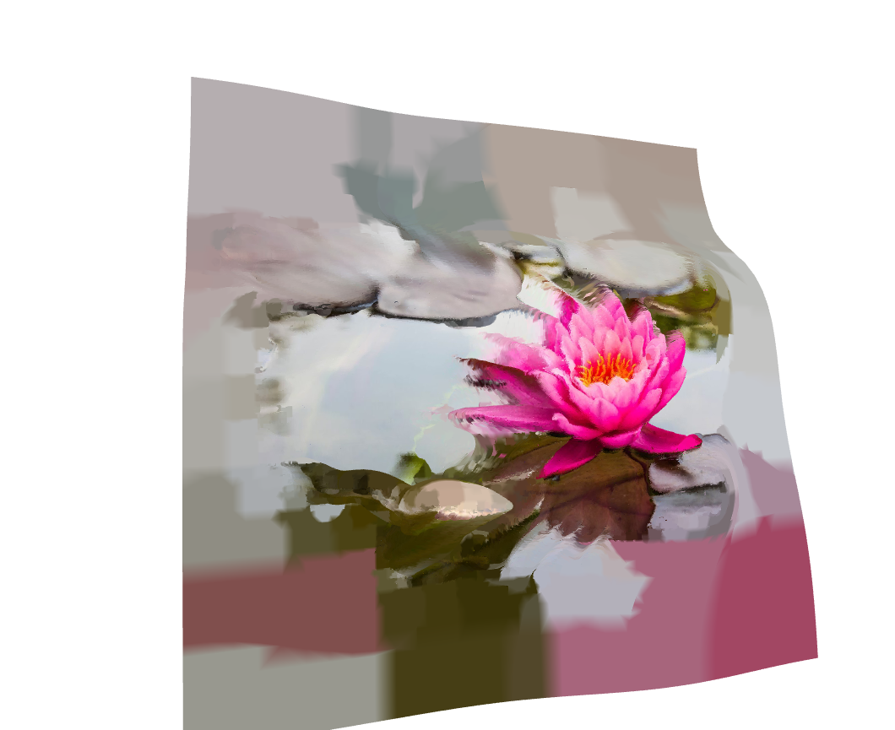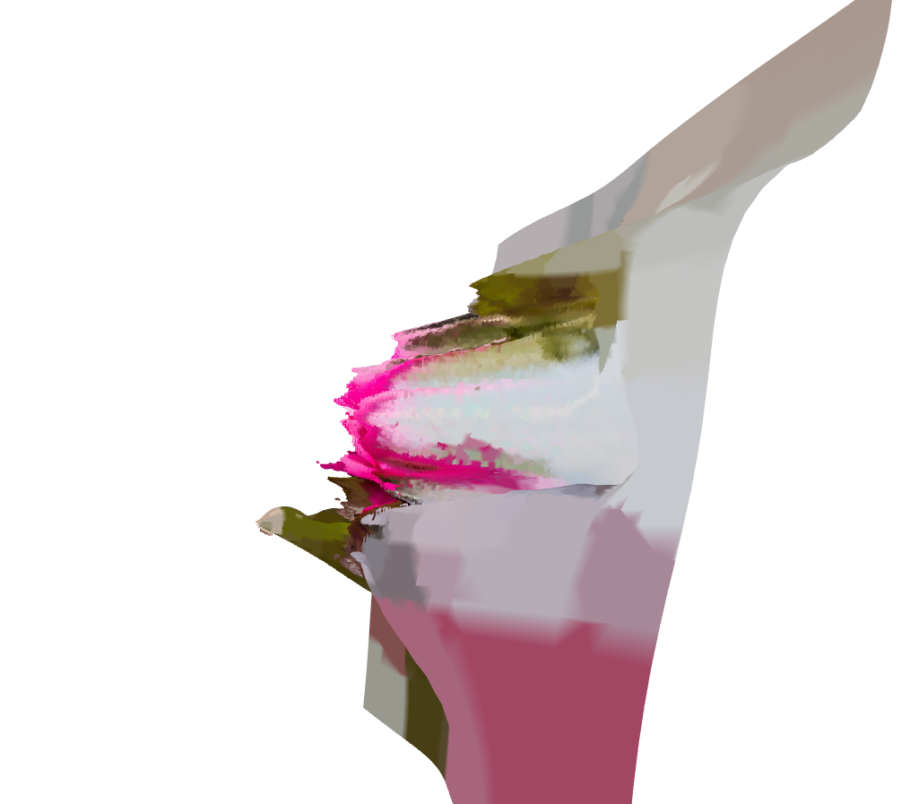

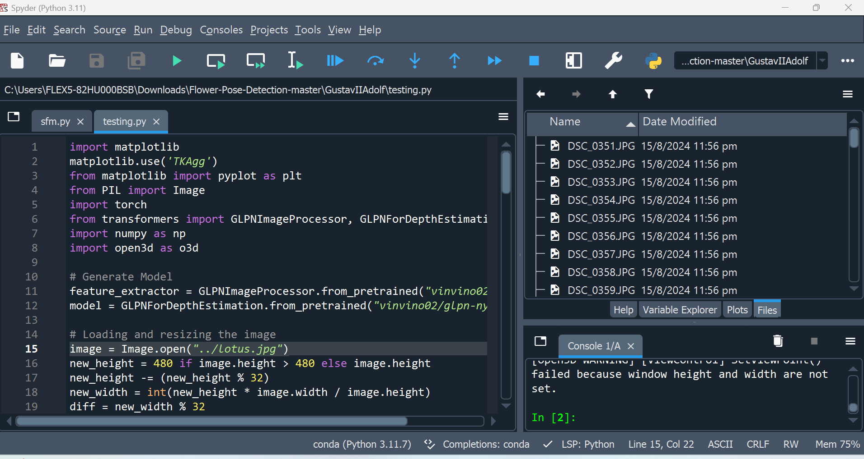

# Second Attempt

Developed a python program that converts multiple 2D images from different angels into 3D mesh using the following libraries.

1. tomlkit
2. tqdm
3. matplotlib
4. scipy
5. cv2
6. numpy
7. os

**Description**

This code implements a Structure from Motion (SfM) pipeline for 3D reconstruction from multiple 2D images. It starts by loading camera intrinsic parameters and downscaling both the images and their corresponding camera matrices. It uses SIFT for feature detection and matching between consecutive images, followed by computing the essential matrix and recovering the camera pose through rotation and translation matrices. The triangulation method reconstructs 3D points from 2D image correspondences, while reprojection error is calculated to assess the accuracy of the 3D points. It also supports bundle adjustment to refine the 3D points and camera parameters by minimizing reprojection error. The final 3D point cloud can be saved as a .ply file, and common points between multiple views are detected and refined for accurate 3D structure estimation.

**Result**

**Input Images Sample taken from different angles**

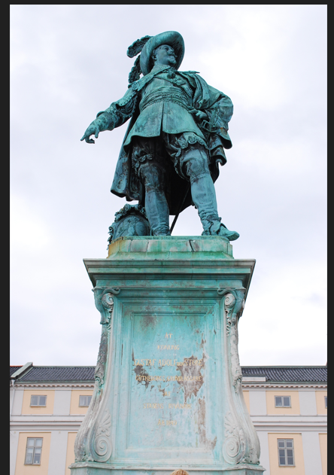

**Output**

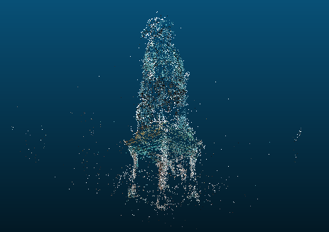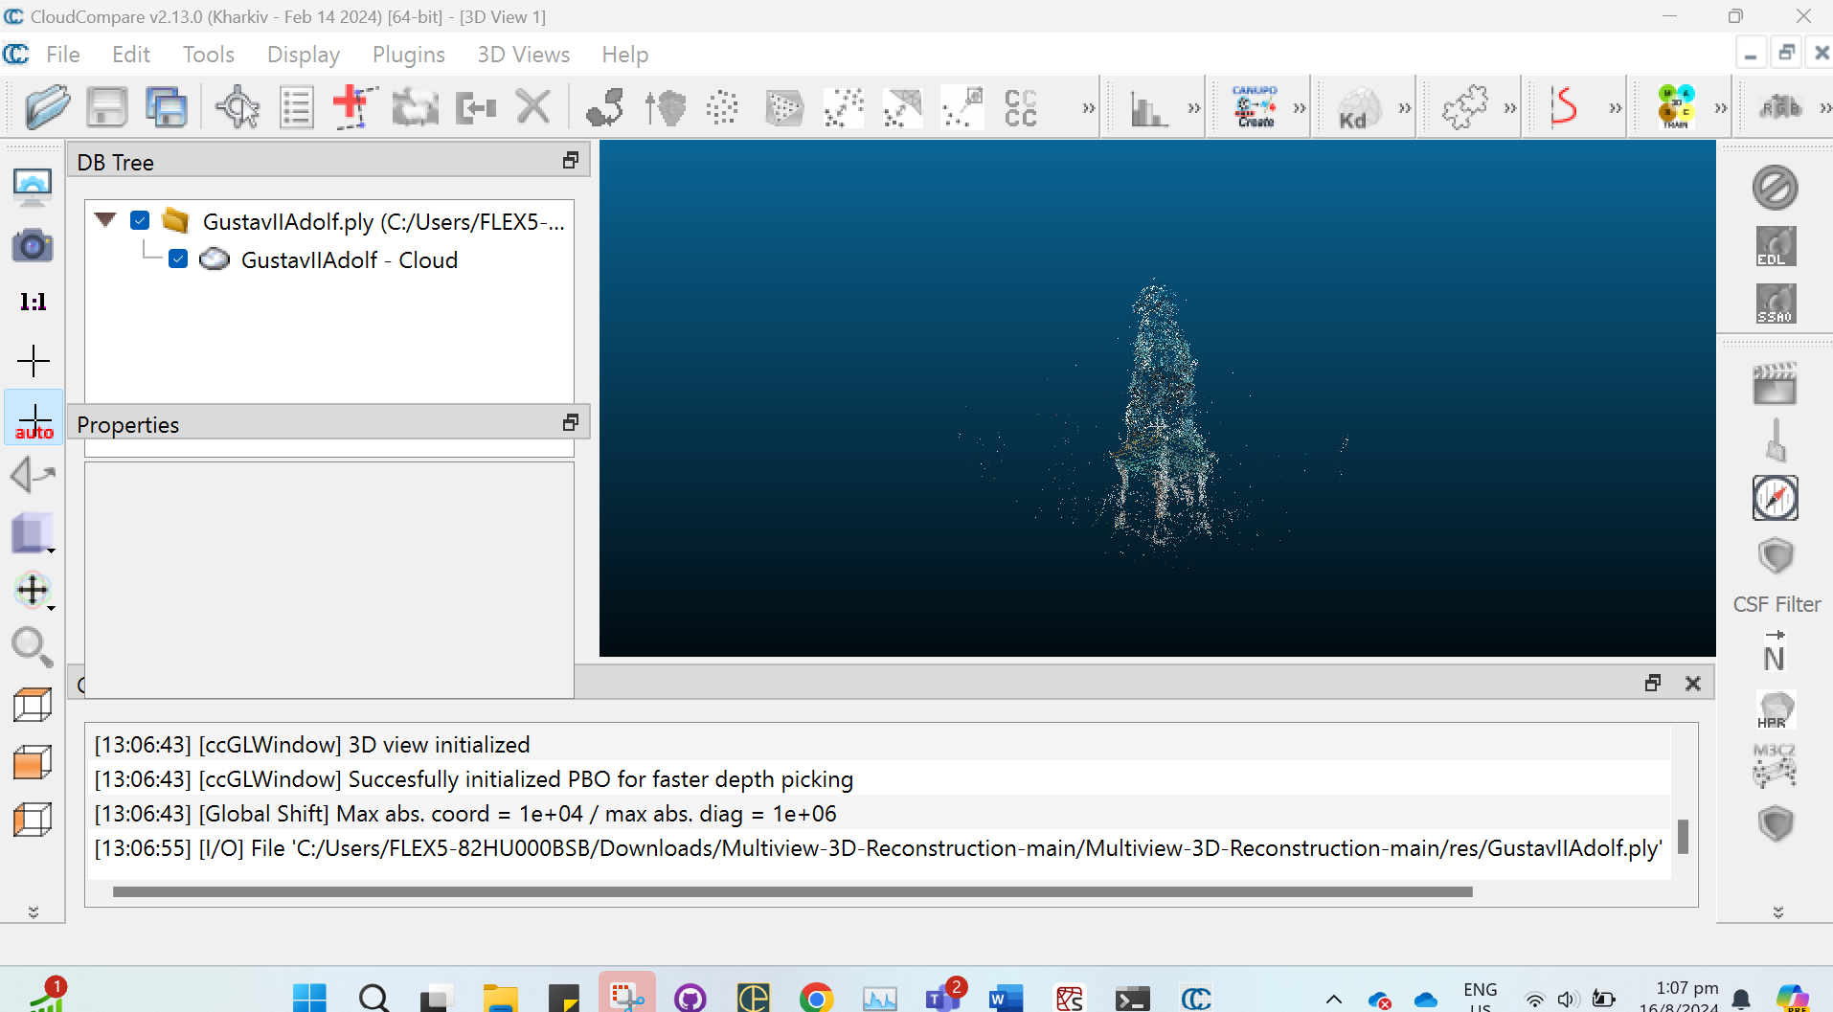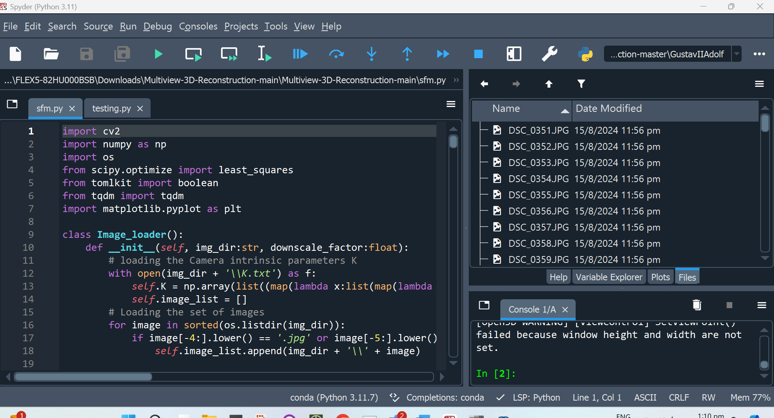

# Third Attempt

**Steps**

1. Captured the required images of orchids (Thai Flower) from different angles
2. Modify the code from last week to take multiple inputs and produce a 3d mesh

**Description**

This code uses a depth estimation model to create a 3D reconstruction from multiple 2D images. It processes a sequence of images by resizing and extracting features using the GLPN model for depth estimation. The code combines the depth information from all images and generates a combined depth map. This map is converted into an RGBD image, which is used to generate a point cloud in Open3D. The point cloud undergoes post-processing, including removing outliers and estimating surface normals. The code then applies Poisson surface reconstruction to create a 3D mesh, which is rotated, visualized, and colored based on the original RGB image. Finally, the 3D mesh is exported as an OBJ file with vertex colors.

**Results**

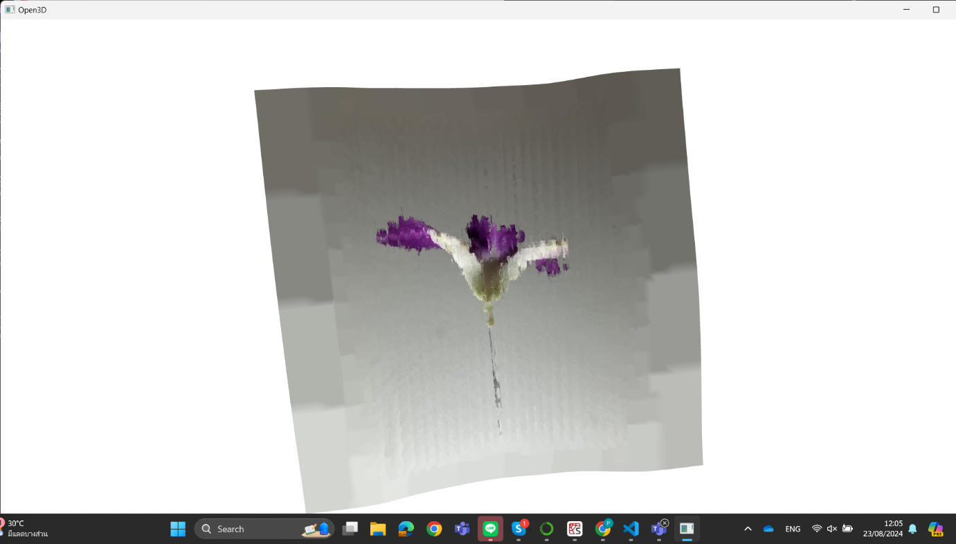

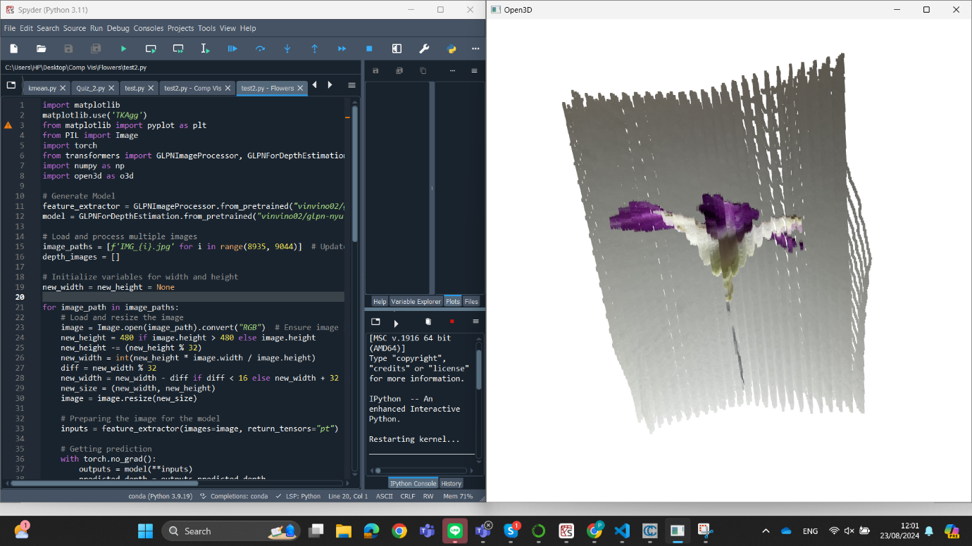



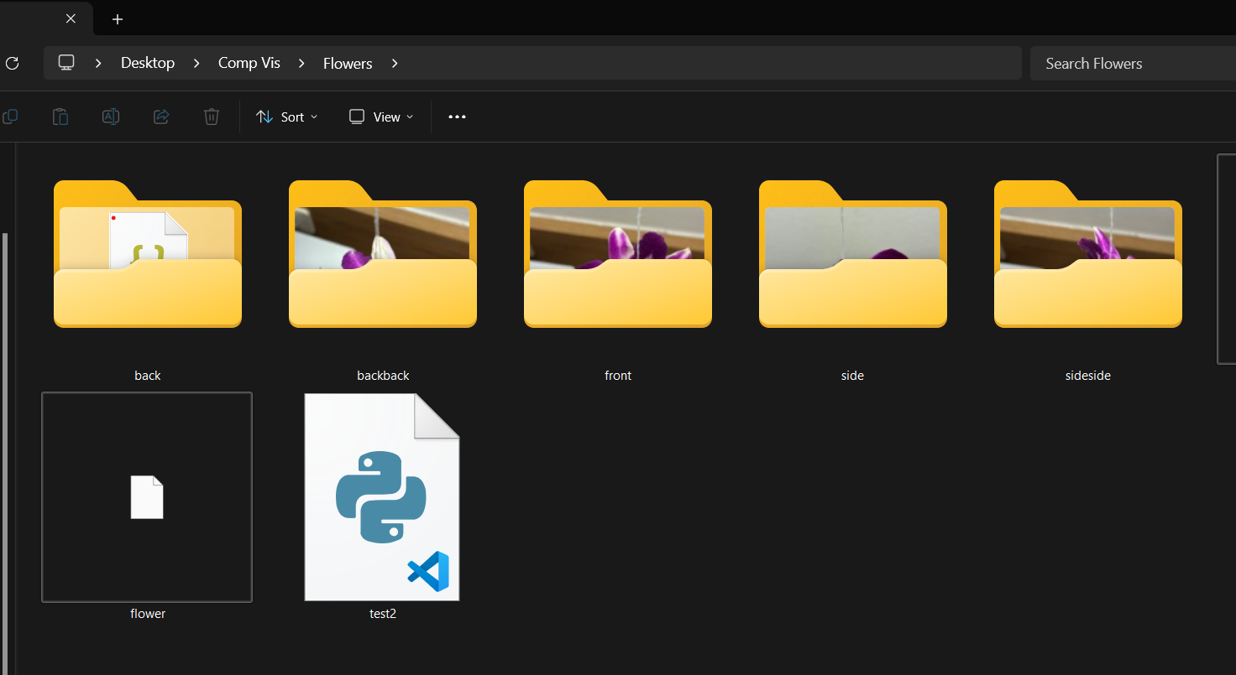

**Original Photo Example**

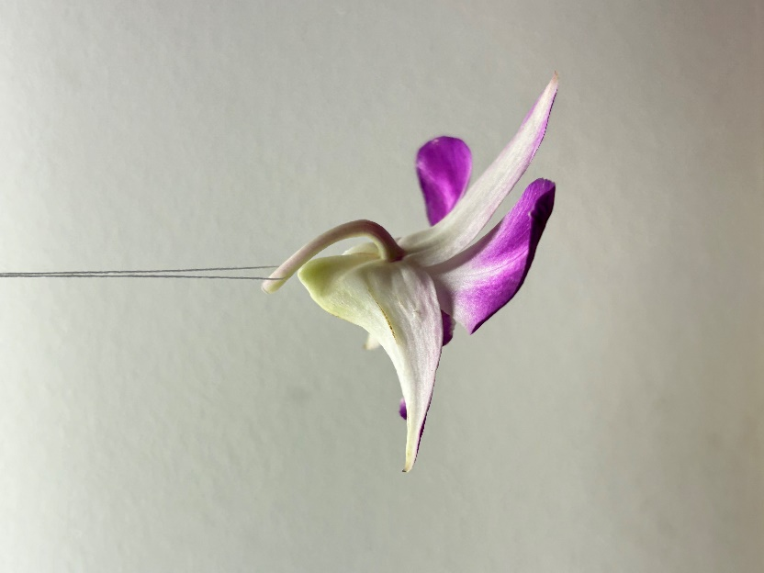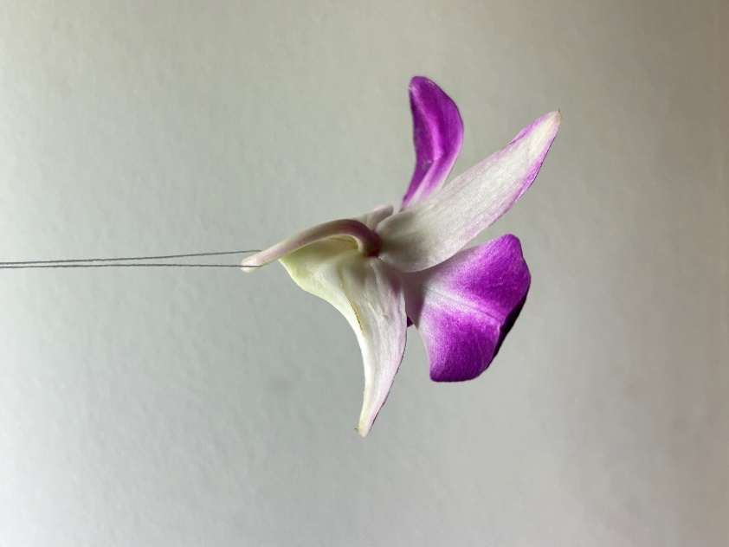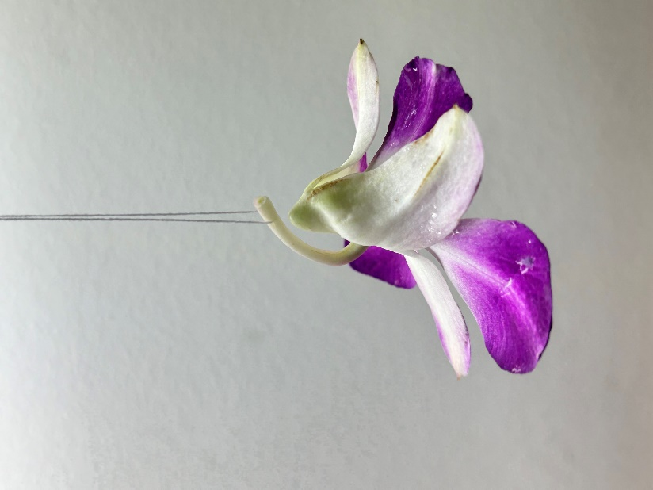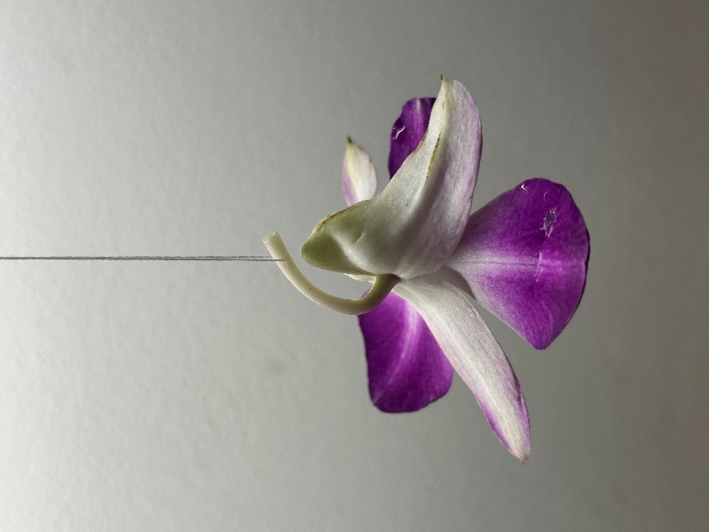

# Our Results So Far

**Jasmine**

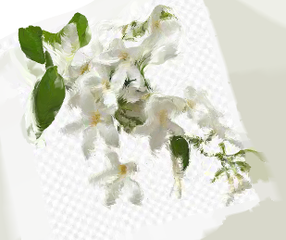

**Orchid**

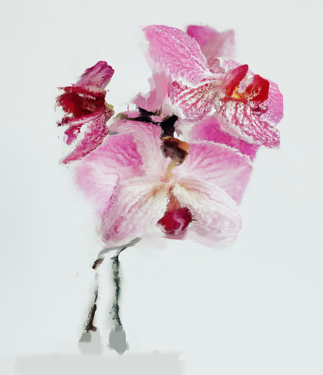

**Golden shower tree**

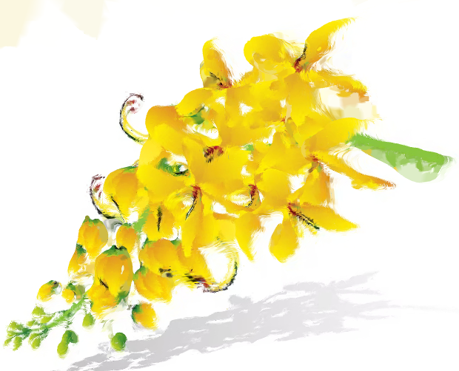

**Tulip**



**Daisy**

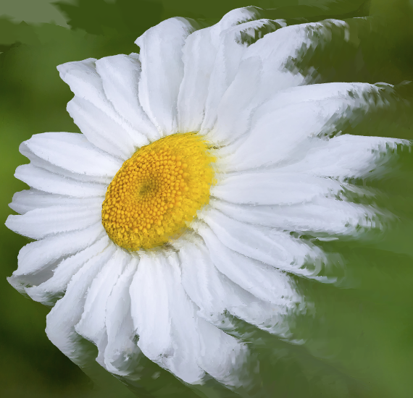

**Hibiscus**

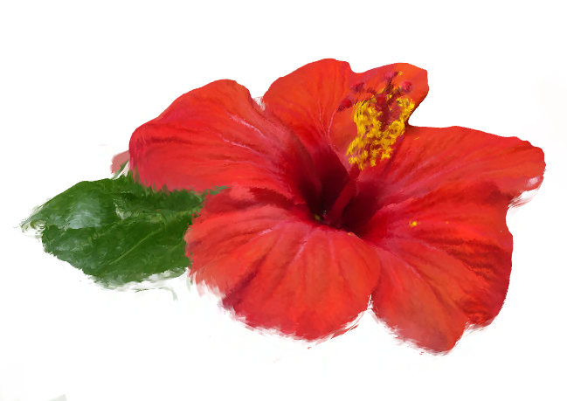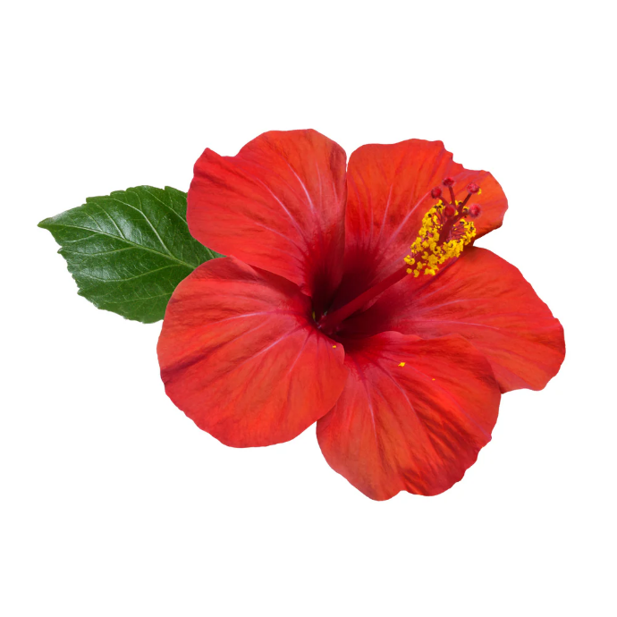

**Lily**

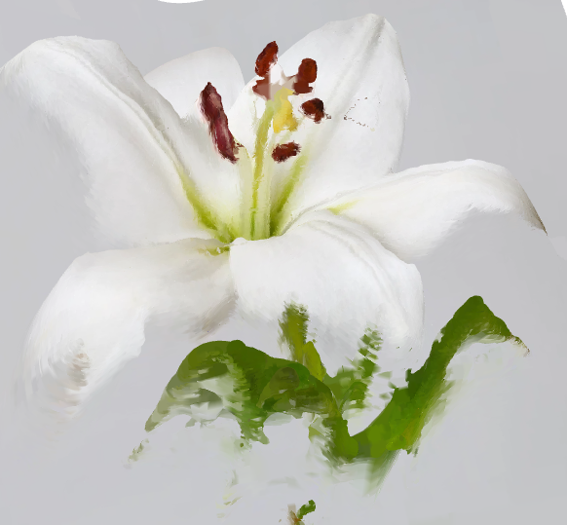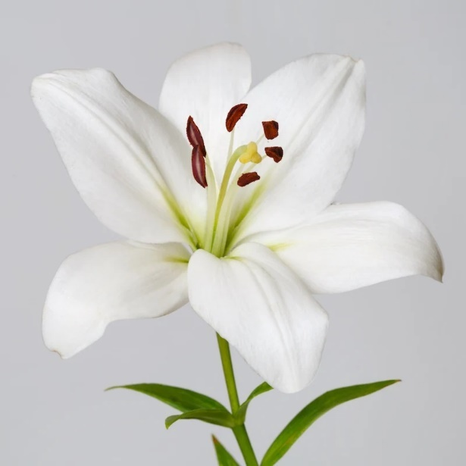

Blue Lotus

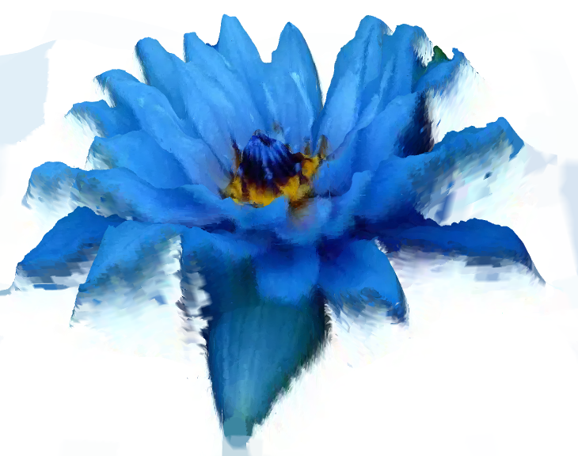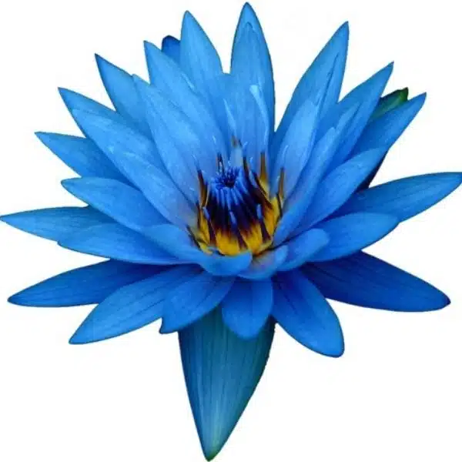

Ratchaphruek flower

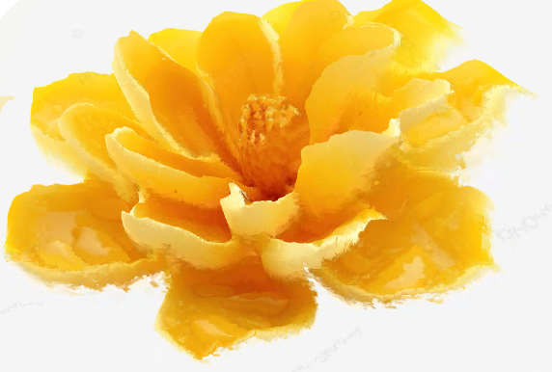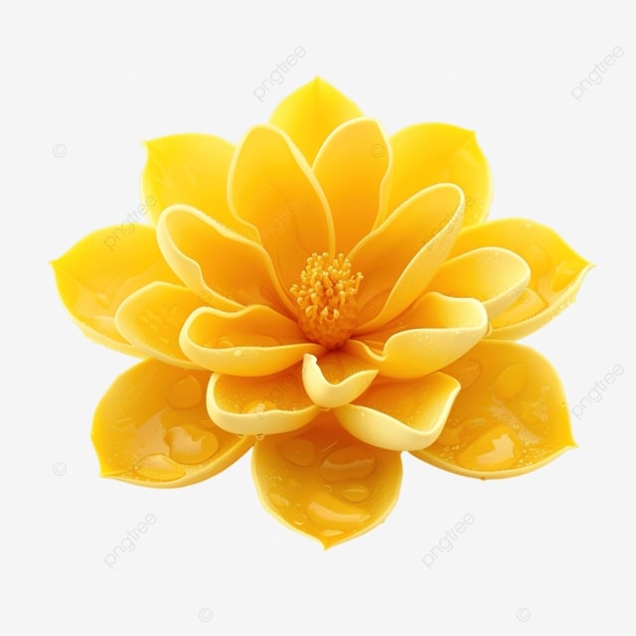

# What is for Future?

1. Modify second attempt to automatically take camera’s intrinsic parameters from images
2. Modify first attempt to take multiple inputs (images) and produce a better mesh